DoConnect
Q&A Forum Platform
Sprint 1 - Project Report
Great Learning Capstone Project
Wipro Training Program
Submitted by: Suryaa R S
GitHub: https://github.com/Suryaa23/DoConnect-Capstone
March 2026

1. Project Overview
DoConnect is a full-stack Q&A forum platform similar to Stack Overflow, built as part of the Great Learning Capstone Project (Sprint 1). The platform allows users to ask questions, provide answers, vote on content, and interact with the community.

1.1 Tech Stack
Layer | Technology | Version
Backend Framework | ASP.NET Core Web API | .NET 10
Frontend Framework | Angular | 19.0
Database | SQL Server | Express Edition
ORM | Entity Framework Core | 10.0
Authentication | JWT Bearer Token | 8.0.1
Real-time | SignalR | 10.0
Password Hashing | BCrypt.Net | 4.0.3
API Documentation | Swagger / Swashbuckle | 6.9.0

1.2 Project Structure
Folder | Description
DoConnect/API/ | ASP.NET Core Web API backend
DoConnect/API/Controllers/ | API endpoints for Auth, Questions, Answers, etc.
DoConnect/API/Models/ | Database entity models
DoConnect/API/Data/ | EF Core DbContext and seed data
DoConnect/API/DTOs/ | Data Transfer Objects
DoConnect/API/Hubs/ | SignalR notification hub
DoConnect/Angular/src/app/ | Angular frontend application
DoConnect/Angular/src/app/components/ | UI components
DoConnect/Angular/src/app/services/ | API service classes
DoConnect/Angular/src/app/guards/ | Route protection guards
DoConnect/Angular/src/app/interceptors/ | HTTP request interceptors

2. Database Design
The DoConnect database consists of 5 tables with proper relationships implemented using Entity Framework Core with SQL Server.

2.1 ER Diagram
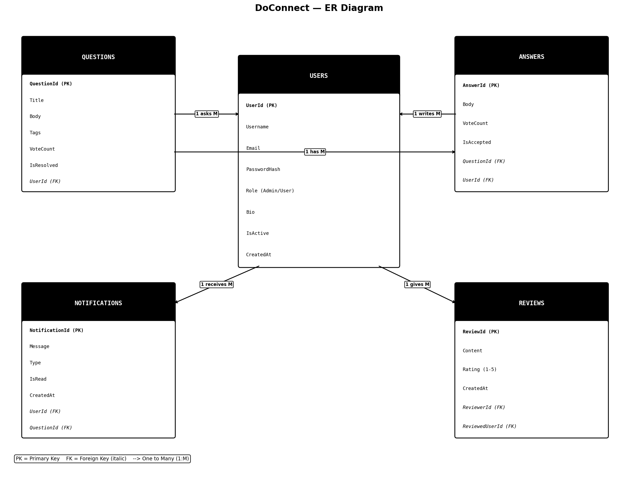

2.2 Tables and Relationships
Table | Primary Key | Description
Users | UserId | Stores all registered users including admin
Questions | QuestionId | Stores questions posted by users
Answers | AnswerId | Stores answers to questions
Notifications | NotificationId | Stores user notifications
Reviews | ReviewId | Stores user reviews with star ratings

2.3 Entity Relationships
- Users (1) --- asks ---> Questions (M)
- Users (1) --- writes ---> Answers (M)
- Questions (1) --- has ---> Answers (M)
- Users (1) --- receives ---> Notifications (M)
- Users (1) --- gives/receives ---> Reviews (M)

3. Features Implemented

3.1 Authentication & Authorization
- User Registration with validation (username, email, password)
- User Login with JWT token generation
- JWT token stored in browser localStorage
- Role-based access control (Admin / User)
- AuthGuard protecting routes from unauthorized access
- HTTP Interceptor adding Bearer token to every API request
- Auto logout on 401 Unauthorized response

3.2 Admin Features
- Admin login with pre-seeded credentials
- Admin Dashboard with platform statistics
- View all registered users
- Activate / Deactivate user accounts
- Delete any question or answer

3.3 Question Management (CRUD)
- Create new question with title, body and tags
- Read / View all questions with pagination
- Search questions by keyword
- Filter questions by status (Open / Resolved)
- Update / Edit own question
- Delete own question
- Vote (upvote / downvote) on questions
- Mark question as Resolved

3.4 Answer Management (CRUD)
- Post answers to questions
- Edit own answers
- Delete own answers
- Vote (upvote / downvote) on answers
- Accept best answer (question owner only)

3.5 Notifications
- Auto notification when someone answers your question
- Real-time notifications using SignalR
- Mark notifications as read
- Notification count badge on navbar

3.6 User Reviews
- Leave star rating (1-5) on other users
- Write review content
- View all reviews on user profile page
- Average rating calculation and display

4. API Endpoints

4.1 Authentication API
Method | Endpoint | Description
POST | /api/auth/register | Register new user
POST | /api/auth/login | Login and get JWT token
GET | /api/auth/me | Get current logged in user

4.2 Questions API
Method | Endpoint | Description
GET | /api/questions | Get all questions with pagination
GET | /api/questions/{id} | Get single question by ID
POST | /api/questions | Create new question
PUT | /api/questions/{id} | Update question
DELETE | /api/questions/{id} | Delete question
POST | /api/questions/{id}/vote | Vote on question
PUT | /api/questions/{id}/resolve | Mark as resolved

4.3 Answers API
Method | Endpoint | Description
GET | /api/answers/question/{id} | Get answers for a question
POST | /api/answers | Post new answer
PUT | /api/answers/{id} | Update answer
DELETE | /api/answers/{id} | Delete answer
POST | /api/answers/{id}/vote | Vote on answer
PUT | /api/answers/{id}/accept | Accept answer

5. Security Implementation

5.1 JWT Authentication
- JWT token generated on successful login
- Token contains UserId, Email, Username and Role claims
- Token expiry set to 7 days
- Token validated on every protected API request

5.2 Middleware Pipeline
Middleware | Purpose
UseHttpsRedirection | Redirects all HTTP requests to HTTPS
UseCors | Allows Angular (localhost:4200) to call the API
UseAuthentication | Validates JWT token on each request
UseAuthorization | Checks user role permissions
MapControllers | Routes requests to appropriate controllers

6. Sprint 1 Requirements Completion
Requirement | Marks | Status
Database schema, tables & relationships | 3 | Completed
Admin Login (CRUD Operations) | 3 | Completed
User Registration & Login | 3 | Completed
Angular Front-End Template | - | Completed
Code Sanitization & Structure | 8 | Completed
Functionalities (CRUD Admin/User) | 8 | Completed
Advanced Features (Reviews, Notifications) | 8 | Completed
Responsiveness & Client-Side Validation | - | Completed
Session Handling (JWT localStorage) | 5 | Completed
Angular + Backend Integration & JWT | 5 | Completed
Testing (Jasmine/Karma Setup) | 7 | Setup Done
GitHub Repository | 3 | Completed

7. GitHub Repository
Repository URL:
https://github.com/Suryaa23/DoConnect-Capstone
- API/ - Complete ASP.NET Core Web API backend
- Angular/ - Complete Angular 19 frontend
- README.md - Project setup instructions

DoConnect - Sprint 1 Report | Suryaa R S | Great Learning | March 2026

